EXPT NO:7 | IMPLEMENT ADVANCED CHART TYPES USING TABLEAU AND  POWER BI
DATE: 14.08.2026

PRE-LAB QUESTIONS (PROVIDE BRIEF ANSWERS TO THE FOLLOWING QUESTIONS)
- Data integration in Business Intelligence (BI)

Data integration is the process of collecting data from different sources—such as Excel files, databases, CRM systems, websites, and ERP systems—and combining it into one consistent view for analysis and reporting.
For example, a company may combine:
- Sales data from a POS system
- Customer data from a CRM
- Product data from an inventory database
This integrated data helps BI tools create dashboards, reports, and insights for better decision-making.

- Difference between a join and a data blend in Tableau
Feature | Join | Data Blend
Where it happens | At the data-source level | Inside the Tableau worksheet
Result | Combines tables into one table | Keeps sources separate and combines aggregated results
Data source | Usually tables from the same source | Can use different data sources
Matching fields | Join keys such as Customer ID | Linking fields such as Region or Date
Example | Joining Orders and Customers tables using Customer ID | Blending an Excel sales file with a database target table by Region
A join is best when tables have detailed row-level data and can be connected using a common key.
A data blend is useful when data comes from different sources or when joining tables directly could duplicate records.

- Relationships and cardinality in Power BI

A relationship connects two tables through a common column, such as CustomerID, ProductID, or Date.
For example:
Customers table Sales table
CustomerID CustomerName SaleID CustomerID Amount
101 Ravi 1 101 500
102 Asha 2 101 800
Here, Customers[CustomerID] is related to Sales[CustomerID].
Cardinality describes how many records in one table can match records in another table.
Cardinality | Meaning | Example
One-to-one (1:1) | One record matches one record | One employee and one employee profile
One-to-many (1:*) | One record matches many records | One customer can place many orders
Many-to-one (*:1) | Many records match one record | Many sales belong to one customer
Many-to-many (:) | Many records on both sides can match | Many students enroll in many courses
In Power BI, the most common and recommended relationship is one-to-many, where a dimension table (Customers, Products, Dates) connects to a fact table (Sales, Transactions).

- Why data quality is crucial during integration
Data quality is important because integrated data must be accurate, consistent, and usable. If different sources use different names, formats, or data types, the BI report can produce incorrect results.
Examples:
- One source uses Male, while another uses M and a third uses male.
- One date is stored as 14/08/2026, while another is stored as 08-14-2026.
- A Customer ID is a number in one source but text in another.
- The same customer appears as Ravi Kumar, R. Kumar, and Ravi K..
Poor data quality can cause failed joins, duplicate records, incorrect totals, misleading dashboards, and poor business decisions.

5. Name two common challenges encountered during data integration.
- Inconsistent data formats and data types
Different sources may store the same information differently—for example, dates as 14/08/2026 versus 08-14-2026, or customer IDs as text in one system and numbers in another.
- Duplicate or missing data
A customer or transaction may appear more than once across sources, or important fields may be empty. This can cause incorrect totals and unreliable BI reports.

IN-LAB EXERCISE:
OBJECTIVE:
To connect, combine, and model data from multiple sources in Tableau and Power BI and create a unified, comprehensive dashboard for holistic analysis.

PROCEDURE:
- Data Collection:
  - Import two datasets:
    - Dataset 1: Sales Data (CSV) → Order ID, Order Date, Region, Sales Amount
    - Dataset 2: Regional Sales Targets (Excel) → Region, Sales Target, Tar get Year
- Data Preparation and Transformation:
  - Clean datasets (e.g., standardize "N. America" → "North America"). • Ensure correct data types (numeric for Sales, date for Order Date).
  - Handle missing values appropriately.
- Data Integration and Modeling:
  - Tableau: Create a join/relationship on the Region field in the Data Source pane.
  - Power BI: Use the Model view to create a relationship on Region; define cardinality (e.g., many-to-one).
- Create Calculated Fields for Comparison:
  - Target Achievement % = (SUM(Sales) / SUM(Sales Target)) * 100
  - Sales vs. Target Variance = SUM(Sales) - SUM(Sales Target)
- Design a Comprehensive Dashboard:
  - Combine visuals from both sources.
  - Add KPI cards: Total Sales, Overall Target Achievement %.
  - Use gauge/bullet charts for region-wise target performance.
  - Combined bar chart: Actual Sales vs. Target by Region.
  - Map visualization: Sales vs. Target Variance by region.
- Validate Data Integrity:
  - Cross-check joined data for accuracy.
  - Ensure dashboard filters correctly update visuals.
- Publishing and Sharing:
  - Tableau: Publish to Tableau Public or Server.
  - Power BI: Publish to Power BI Service and share.
Experiment Datasets:
  - Dataset 1: Retail Sales Data (CSV) → Order ID, Order Date, Region, Sales
  - Dataset 2: Regional Sales Targets (Excel) → Region, Sales Targe t, Target Year

TABLEAU:

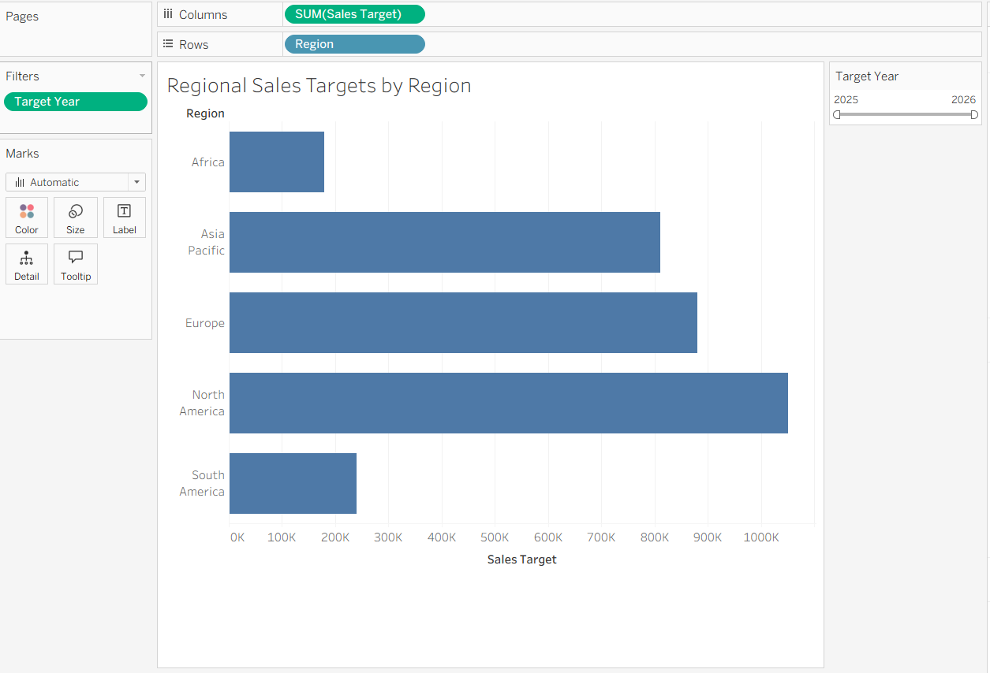
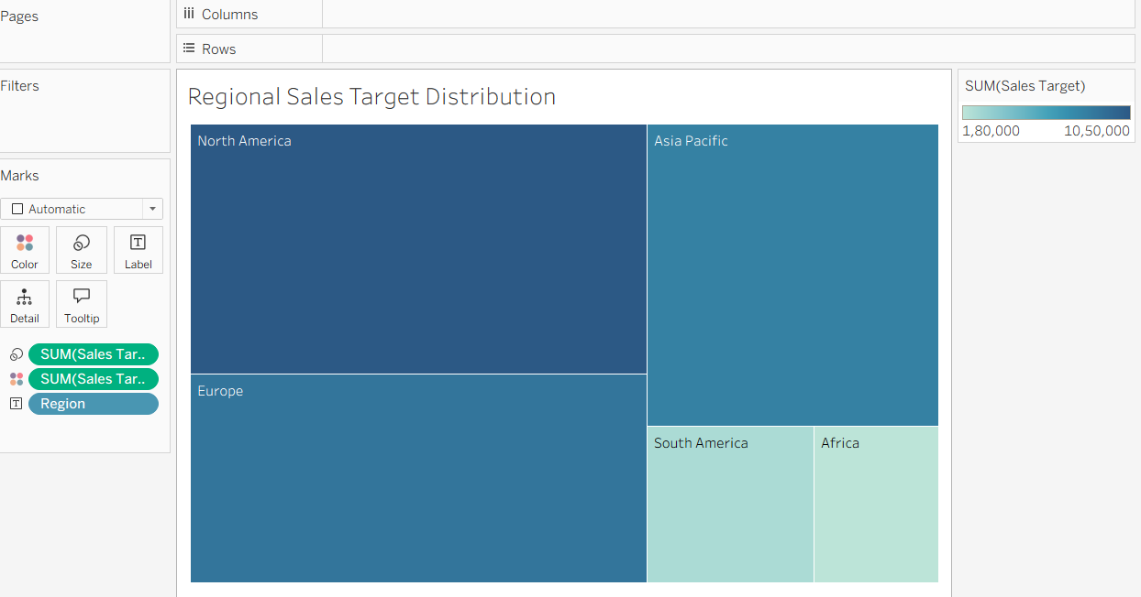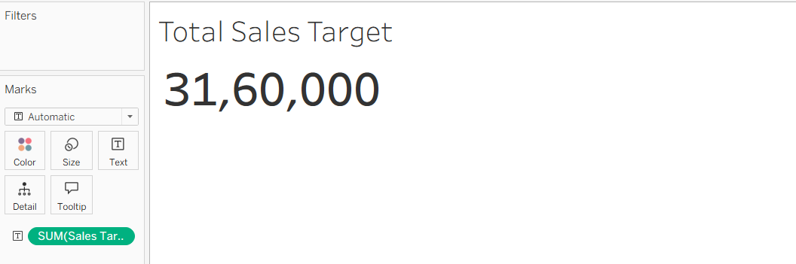
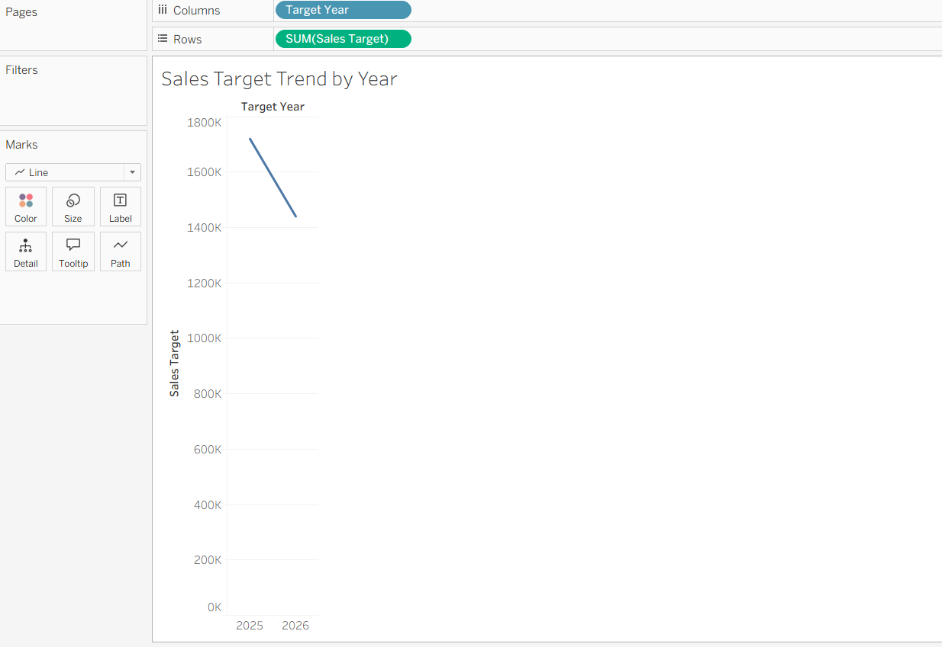
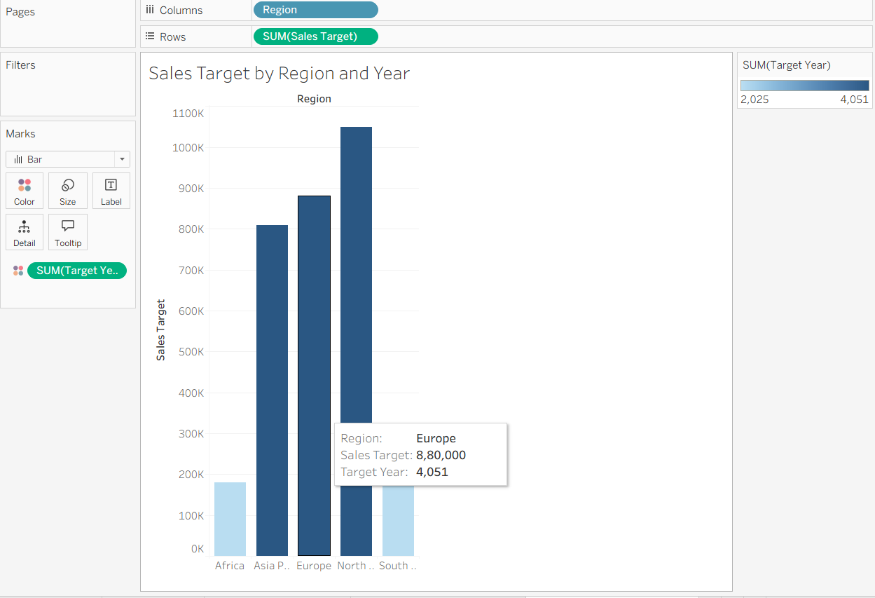

POWER BI:

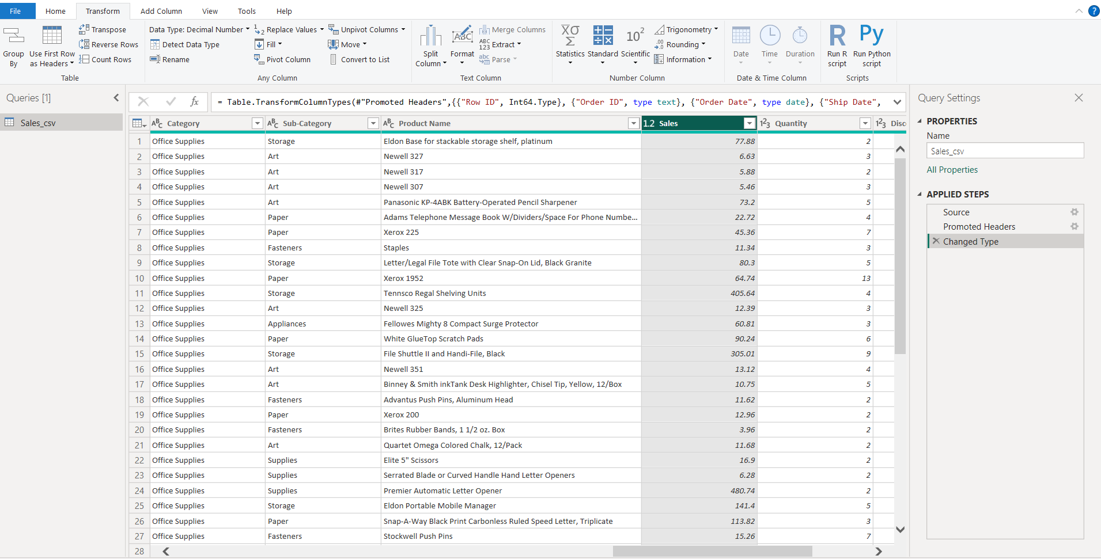
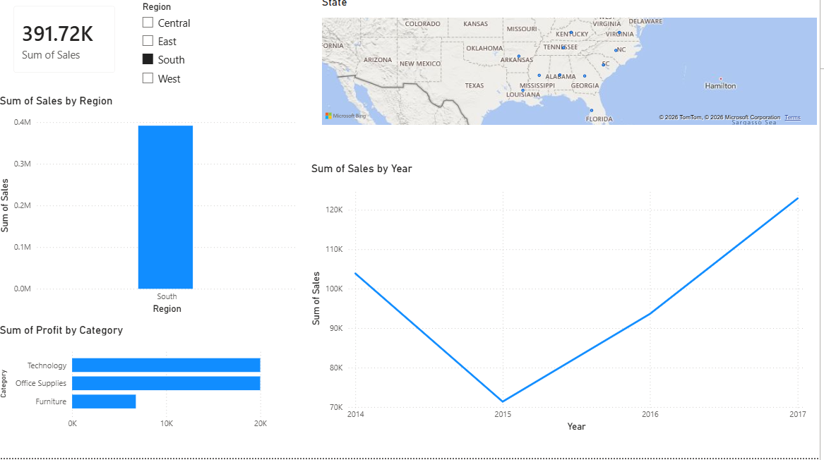

POST-LAB QUESTIONS (PROVIDE BRIEF ANSWERS TO THE FOLLOWING QUESTIONS)
- More complete picture from targets + sales
Sales data alone shows actual performance—such as revenue by region, product, or month. Adding sales targets adds the expected benchmark, so you can see whether performance was good, poor, or merely high in absolute terms.
For example, ₹10 lakh in sales may look strong, but if the target was ₹15 lakh, the region is underperforming by ₹5 lakh. Conversely, ₹7 lakh may be excellent if the target was ₹5 lakh.
- Join/relationship used
Typically, this uses a left join from the sales table to the targets table, matched on shared fields such as:
- Region
- Product/category
- Month or quarter
A left join is appropriate because every actual sales record should remain in the analysis, even when a matching target is missing. Missing targets can then be flagged and investigated instead of silently removing sales records, as an inner join would.
- Granularity and key-matching challenges
Common issues include:
- Different granularity: sales may be daily and product-level, while targets may be monthly and region-level. Sales should first be aggregated to the target level before comparison.
- Inconsistent names: e.g., North Region vs. North, or Bengaluru vs. Bangalore.
- Different time formats: dates may need conversion into a common month/quarter key.
- Missing or duplicate target rows: duplicated targets can inflate the target after joining.
A mapping table and standardized keys help resolve naming differences, while careful aggregation prevents invalid comparisons.
- Value of variance calculations
Variance calculations turn raw data into action-oriented performance measures:
\[ \text{Sales Variance} = \text{Actual Sales} - \text{Target Sales} \]\[ \text{Variance \%} = \frac{\text{Actual Sales} - \text{Target Sales}}{\text{Target Sales}} \times 100 \]
They help managers identify overperforming and underperforming regions, products, and time periods; prioritize corrective action; set realistic future targets; and replicate successful strategies from high-performing segments.
- Additional data to integrate
A valuable next source would be marketing campaign data—campaign spend, channel, dates, audience, leads, and conversions.
This could reveal:
- Whether target achievement improved after specific campaigns
- Which channels generate the highest sales relative to spend
- Which regions or products respond best to promotions
- Whether weak sales are due to poor demand, insufficient marketing, or sales-execution issues
Customer demographics could add another layer, showing which customer segments are most likely to buy and helping tailor marketing, product selection, and sales targets.
11:23 AM

RESULT:

The retail sales and regional targets datasets were successfully connected, cleaned, and integrated in Tableau and Power BI. Relationships between the sources created a unified data model. The dashboard visualized sales performance against targets, enabling variance analysis and providing insights into regional performance not possible with a single data source.

ASSESSMENT

Description |  | Max Marks | Marks Awarded
Pre Lab Exercise |  | 5
In Lab Exercise |  | 10
Post Lab Exercise |  | 5
Viva |  | 10
 | Total | 30
 | Faculty Signature

